**Assignment -I**

* **Ashok Pande (BCT015)**

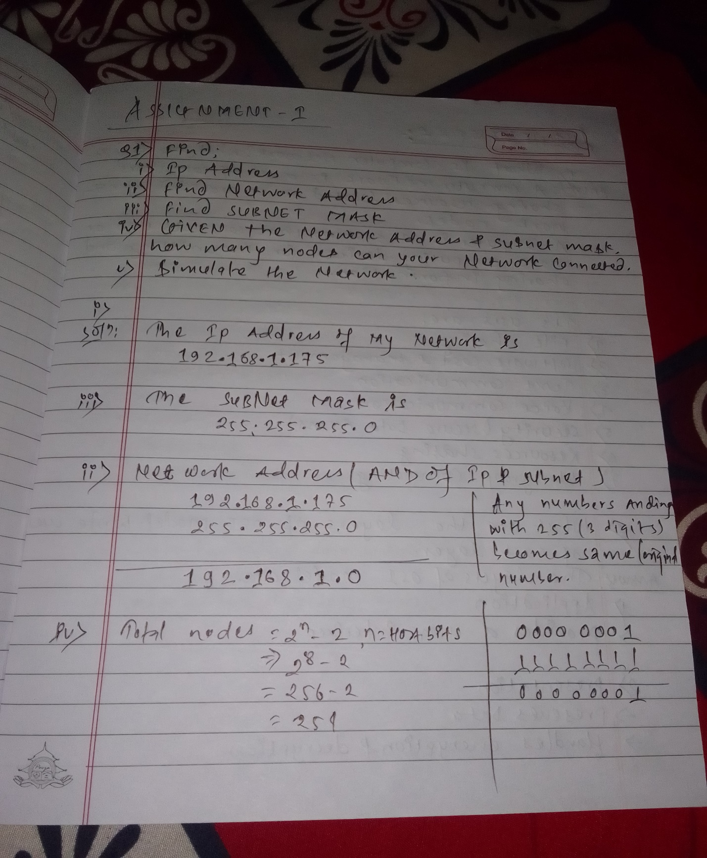

**Simulation of same network(192.168.1.175)**

